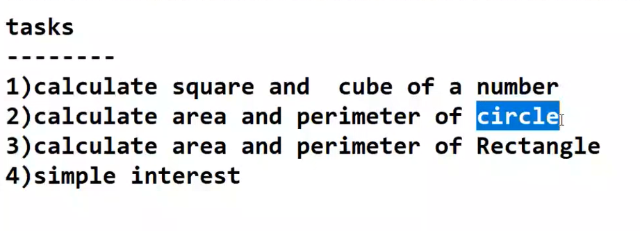

#calculate the area of circle  
  
radius = int(input("Enter the radius value:"))  
pi = 3.1415926535897932384626433832795  
area = pi*radius**2  
  
  
print("Area of circle is :",area)

Enter the radius value:14

Area of circle is : 615.7521601035994

# calculate the area of retangle  
  
Length = int(input("Enter the length value :"))  
Height= int(input("Enter the height value :"))  
area = Length*Height  
  
print("Area of retangle is :",area)

Enter the length value :100

Enter the height value :50

Area of retangle is : 5000

#calculate the perimeter of circle  
  
radius = int(input("Enter the radius value:"))  
pi = 3.1415926535897932384626433832795  
perimeter = 2*pi*radius  
  
print("perimeter of circle is :",perimeter)

Enter the radius value:14

perimeter of circle is : 87.96459430051421

# calculate the perimeter of retangle  
  
Length = int(input("Enter the length value :"))  
Height= int(input("Enter the height value :"))  
perimeter = 2*(Length+Height)  
  
print("perimeter of retangle is :",perimeter)

Enter the length value :100

Enter the height value :50

perimeter of retangle is : 300

#calculate the square of a given number  
num = int(input("Enter the number to find square :"))  
res = num**2  
print ("square of ",num," is : ",res)

Enter the number to find square :2

square of 2 is : 4

#calculate the cube of a given number  
num = int(input("Enter the number to find cube :"))  
res = num**3  
print ("Cube of ",num," is : ",res)

Enter the number to find cube :2

Cube of 2 is : 8

#calculate the simple interest  
  
principle = int(input("Enter your principal amount :"))  
interest = int(input("Enter your interest :"))  
no_of_years = int(input("Enter the No of years :"))  
SI = (principle*interest*no_of_years)/100  
print("Simple Interest :",SI)  
  
Amount = principle+SI  
print("Total Amount is :",Amount)

Enter your principal amount :100

Enter your interest :5

Enter the No of years :2

Simple Interest : 10.0

Total Amount is : 110.0